Title
Implementation of Terraform Infrastructure Automation Using GitHub and Jenkins CI/CD Pipeline
Objective
The objective of this task is to install and configure Terraform, write basic Terraform configurations, manage infrastructure state, and automate Terraform execution using a Jenkins CI/CD pipeline integrated with a GitHub repository. The goal is to demonstrate Infrastructure as Code (IaC) practices along with continuous integration and automated deployment using Jenkins.
Prerequisites
- Windows system with internet access
- Visual Studio Code installed
- Terraform installed on local machine
- GitHub account
- Jenkins server running on Linux (EC2 instance)
- Git installed on Jenkins server
- Terraform installed on Jenkins server
Errors Faced and How They Were Fixed
Error 1: Terraform Command Not Recognized
Cause:
Terraform binary was downloaded but not added to system PATH.
Fix:
Added Terraform installation directory to system environment variables and reopened the terminal.
Error 2: Inconsistent Dependency Lock File
Cause:
Terraform provider configuration was changed (from local_file to random_pet) without reinitializing providers.
Fix:
Re-ran the following command to update provider dependencies:
terraform init
Error 3: Terraform Apply Fails After Resource Change
Cause:
Existing resource was still tracked in the Terraform state file.
Fix:
Terraform automatically planned resource replacement. Confirmed changes by typing yes during terraform apply.
Error 4: Jenkins Pipeline Fails at Terraform Command
Cause:
Terraform was not installed on the Jenkins server.
Fix:
Installed Terraform on Jenkins EC2 instance using HashiCorp official repository and verified installation using:
terraform -v
Error 5: Jenkins Workspace Not Showing Terraform Output Files
Cause:
Pipeline was not reaching the apply stage initially.
Fix:
Corrected pipeline script and re-ran the job. Verified files under:
/var/lib/jenkins/workspace/terraform-pipeline
Conclusion
In this project, Terraform was successfully installed and configured on both local and Jenkins environments. Basic Terraform resources were created, modified, destroyed, and validated while observing state file behavior. The Terraform code was version-controlled using GitHub, and an automated Jenkins pipeline was implemented to perform Terraform lifecycle operations including init, validate, plan, and apply. This setup demonstrates a complete Infrastructure as Code workflow integrated with CI/CD, ensuring repeatability, automation, and consistency in infrastructure provisioning

- Open a web browser.
- Go to the official Terraform website: developer.hashicorp.com/terraform/install.
- This page contains Terraform installation options for different operating systems
- From the left menu, select Windows.
- Under Binary download, choose AMD64 (for 64-bit Windows systems).
- Click on Download to download the Terraform ZIP file.

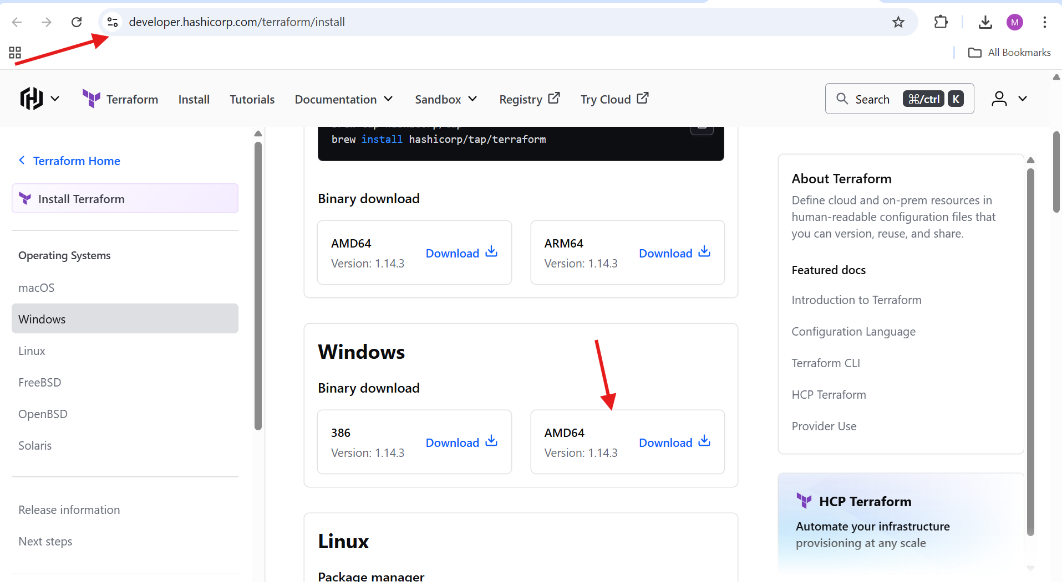
- Open File Explorer.
- Navigate to the Downloads folder.
- Locate the downloaded file: terraform_1.14.3_windows_amd64.zip.
- Right-click or select Extract All.

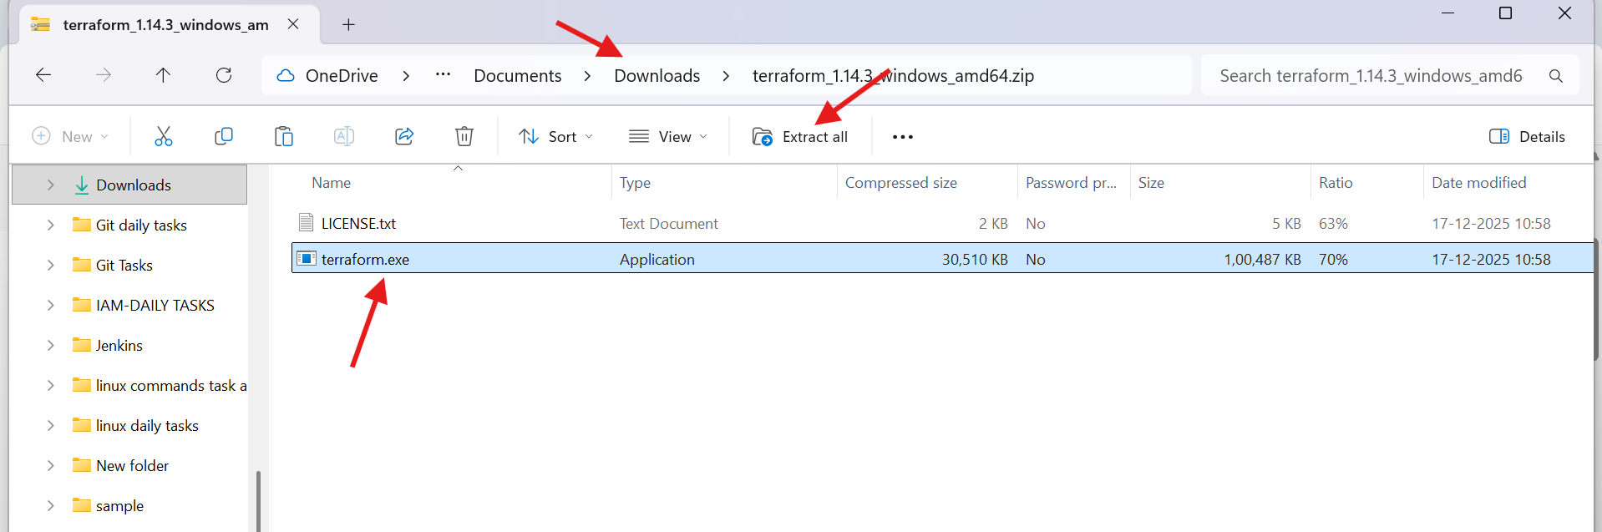

- The “Extract Compressed (Zipped) Folders” window opens.
- Click on Browse to choose a custom extraction location.

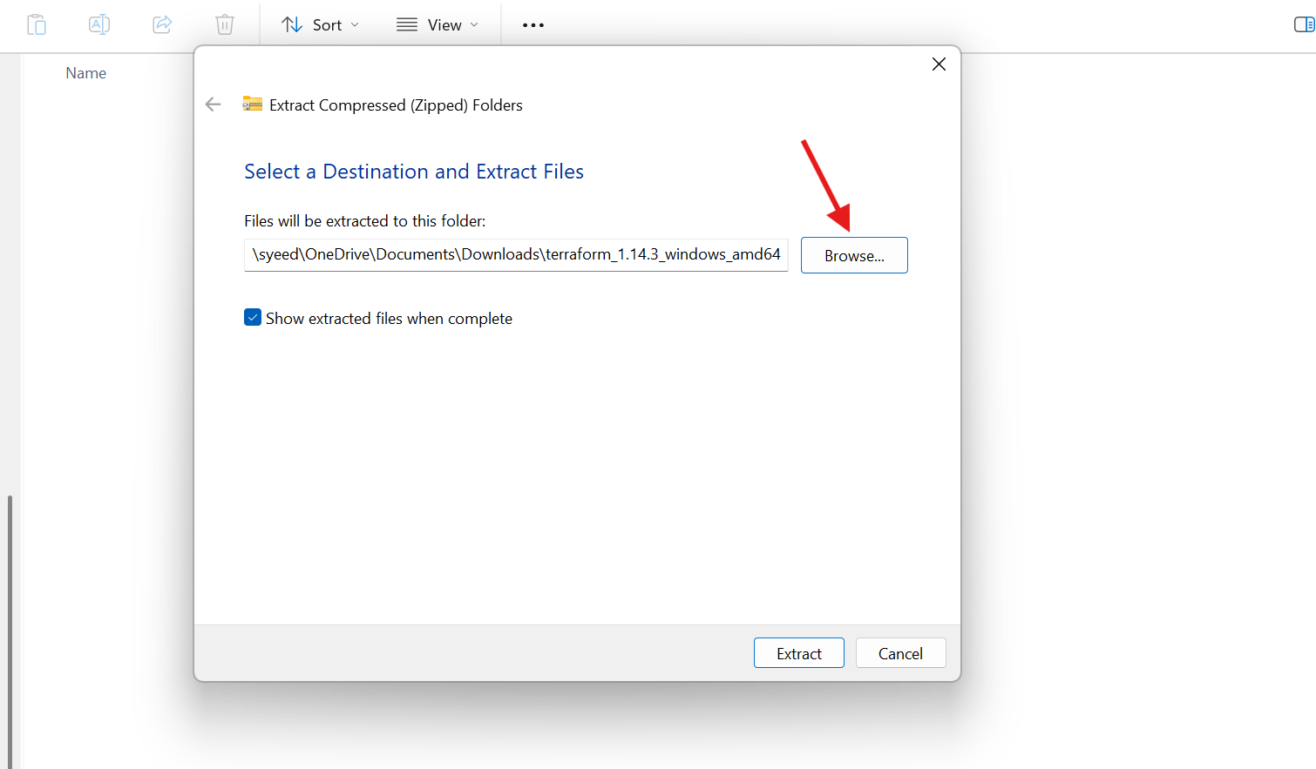
- Navigate to This PC → Acer (C:).
- Select or create a folder named Terraform.
- Click Select Folder to confirm the destination.

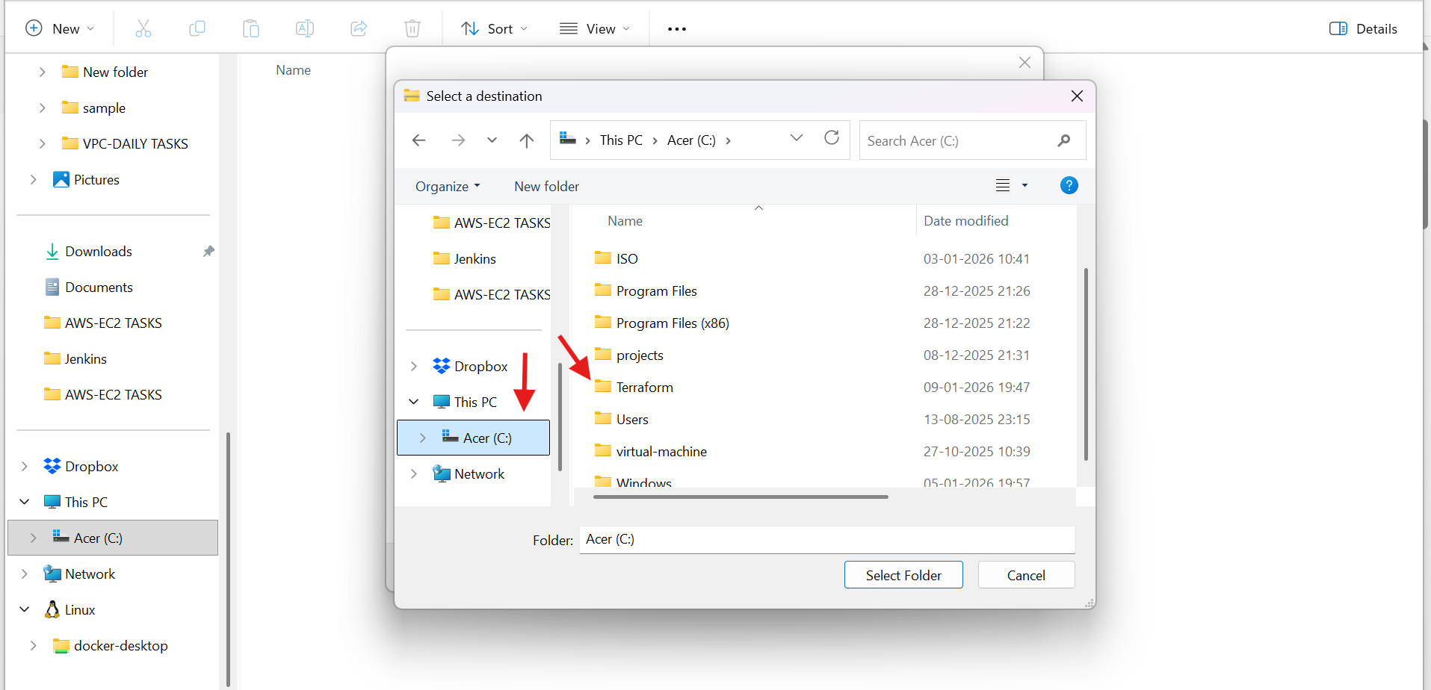
- Confirm that the destination path is C:\Terraform.
- Click on Extract.
- Terraform files are extracted to the selected folder.

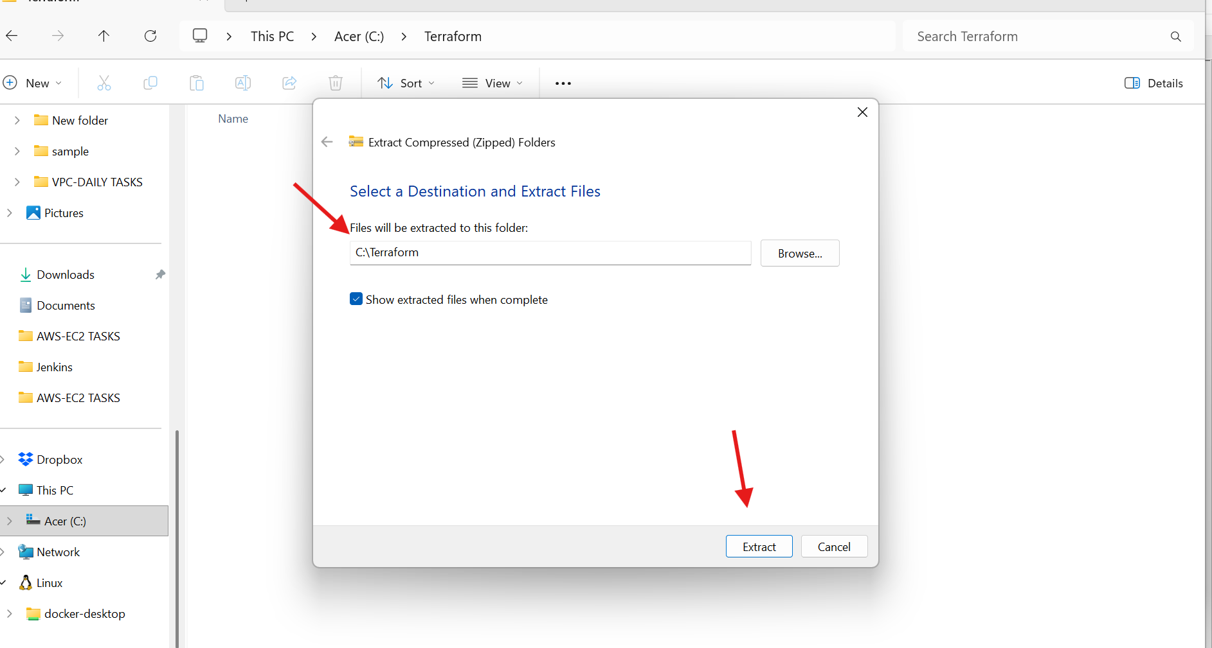
Click on the Start Menu.
Search for Edit the system environment variables.
Click Open to launch system properties.

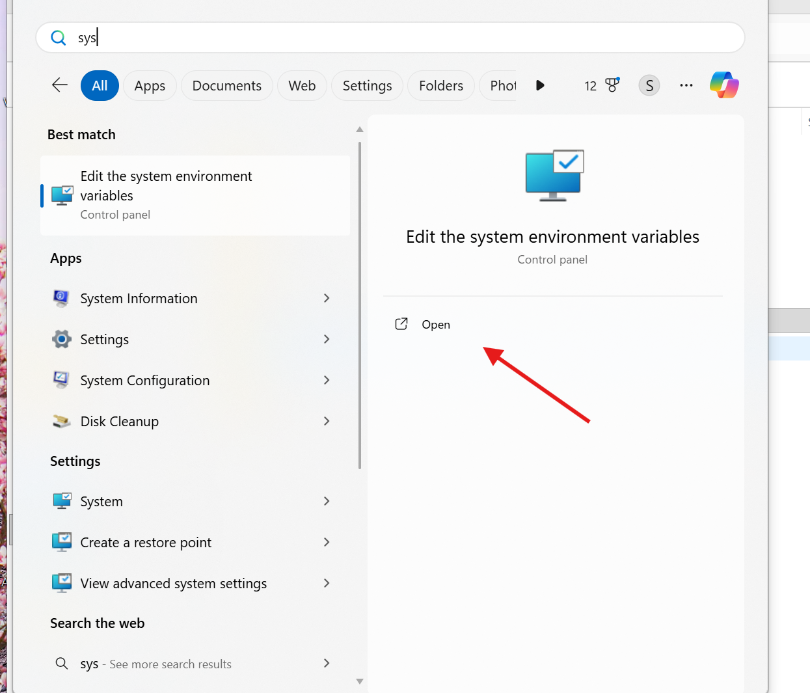
- Open Visual Studio Code.
- Go to the Extensions tab.
- Search for Terraform.
- Install HashiCorp Terraform extension (verified publisher).

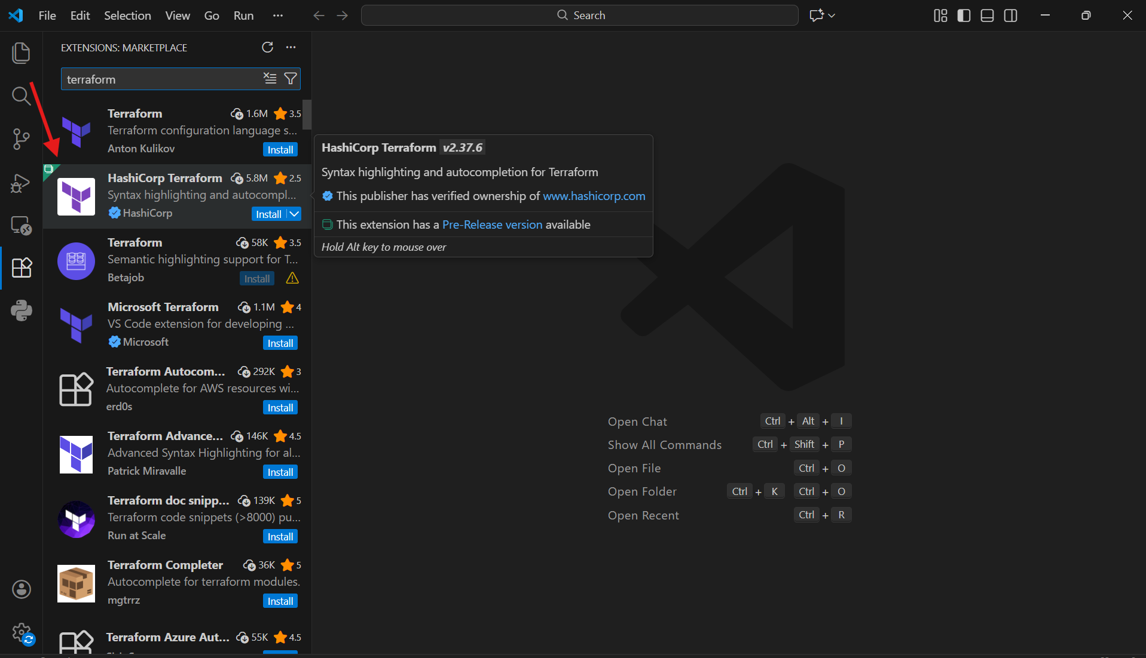
- In VS Code, go to Explorer.
- Click on Open Folder.
- Select the folder where you want to write Terraform code (example: Terraform Basic).

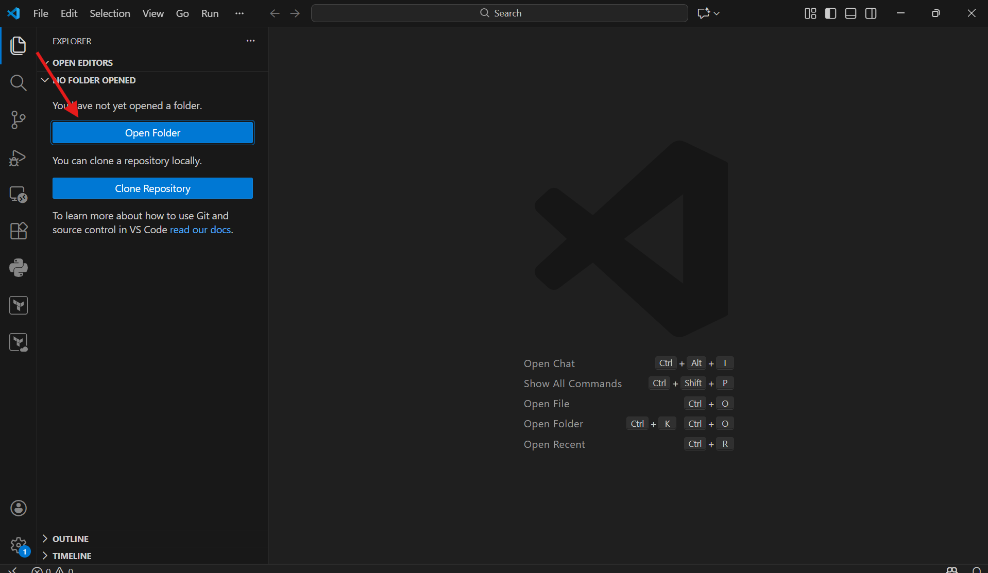

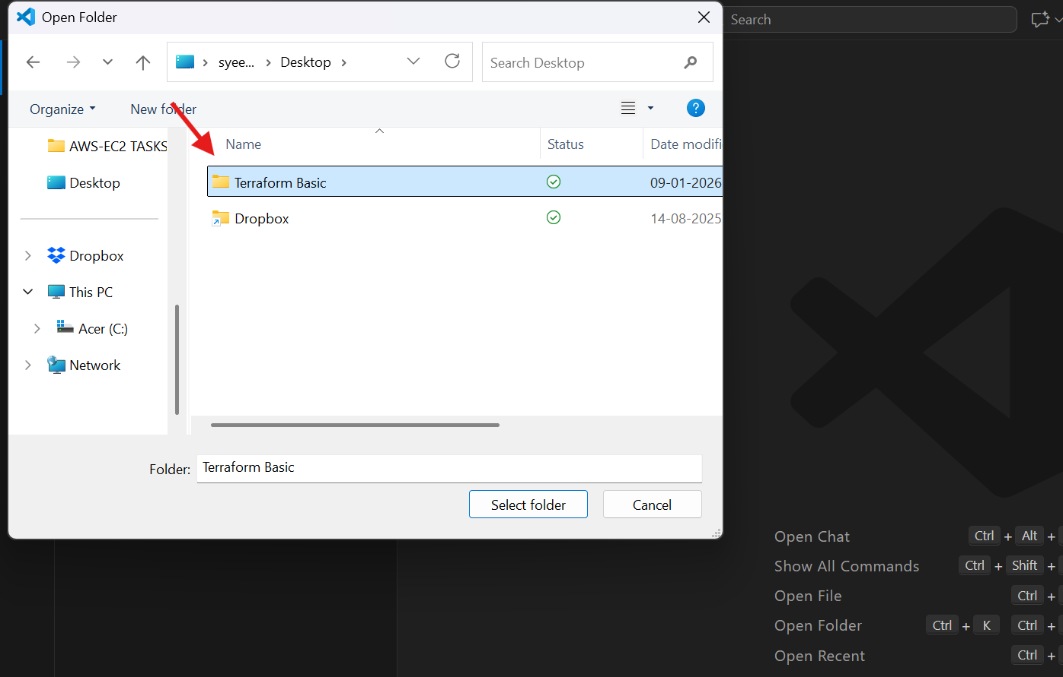

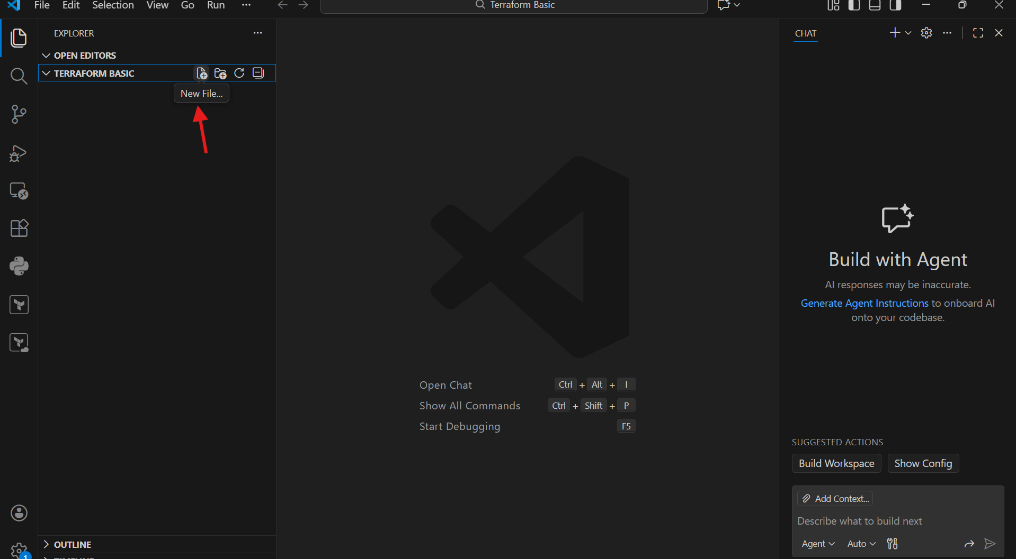
- Inside the opened folder, click New File.
- Create a file named main.tf.
- This file will be used to write Terraform configuration code.

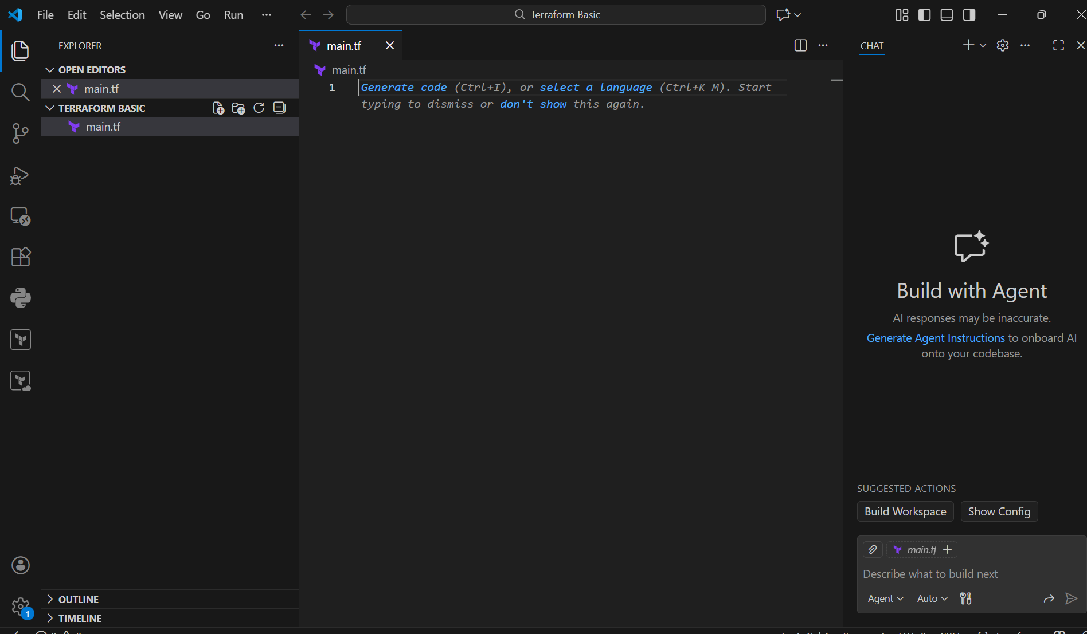
- Open main.tf in VS Code.
- Define a Terraform resource using the local_file provider.
- Specify the resource name and the filename.
- Save the file using Ctrl + S.

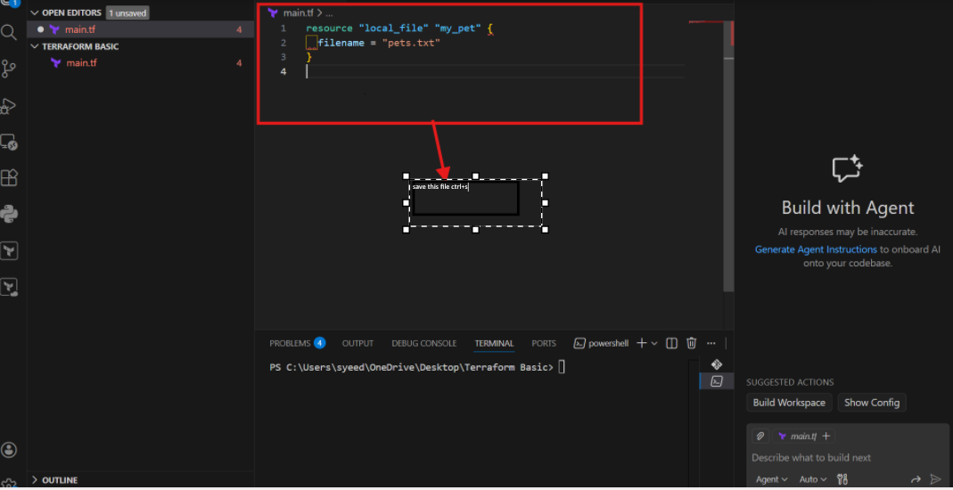
- Open the integrated terminal in VS Code.
- Navigate to the Terraform working directory.
- Run the command:
- terraform init
- Terraform downloads the required provider plugins.
- A .terraform.lock.hcl file is created.
- Initialization completes successfully.

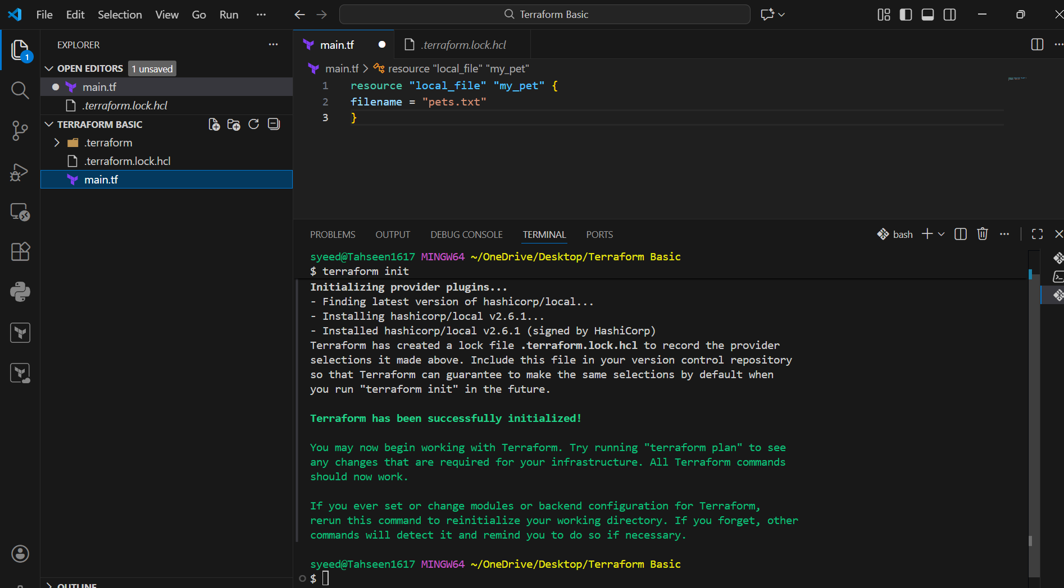

- Update main.tf to include file content.
- Run the command:
- terraform apply
- Terraform displays the execution plan.
- Type yes to approve the changes.
- Terraform creates the file and updates the state file.

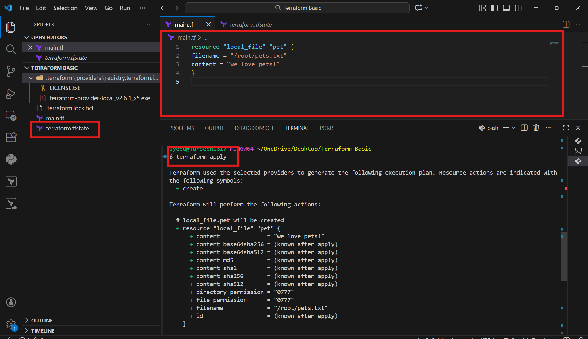

- Replace the local file resource with a random_pet resource.
- Define attributes such as prefix, separator, and length.
- Save the updated configuration file.
- Run:
- terraform apply
- Terraform throws an inconsistent dependency lock file error.
- Error occurs due to provider mismatch after configuration change
- Fix the issue by running:
- terraform init
- Terraform reinitializes backend and providers.
- Required providers are installed successfully.
- Dependency lock file is updated

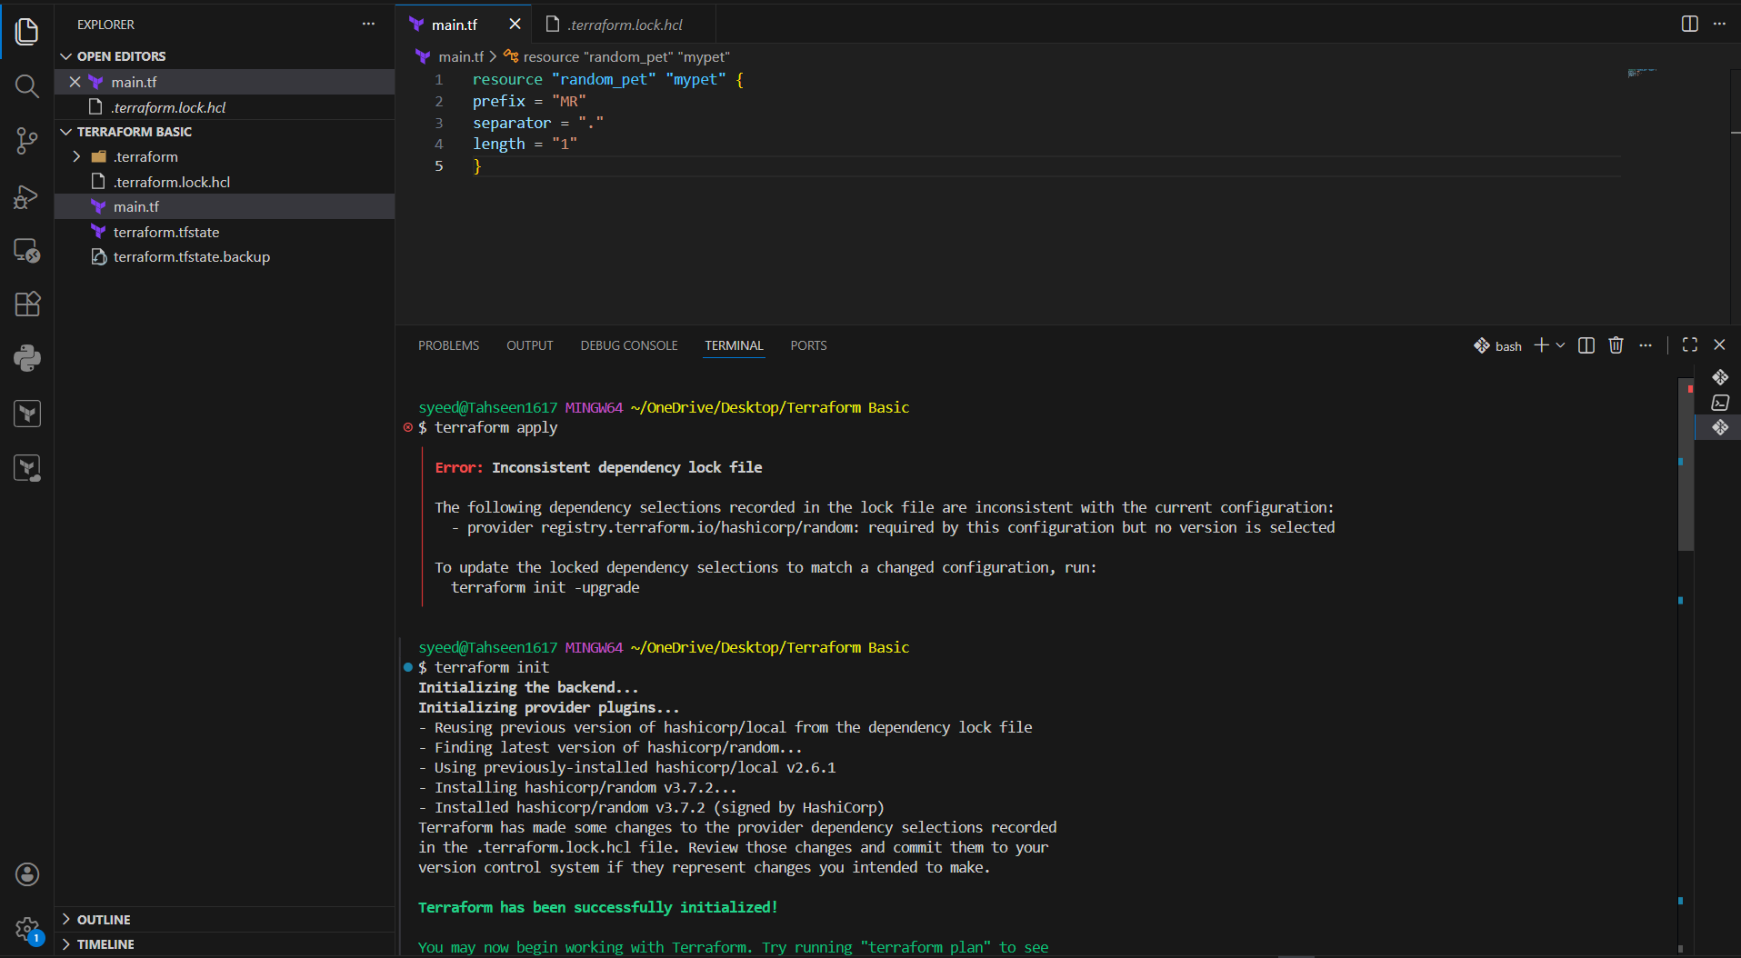
Run:
terraform apply
Terraform plans to destroy the old resource and create a new one.
Confirm by typing yes.
Local file resource is destroyed.
Random pet resource is created successfully

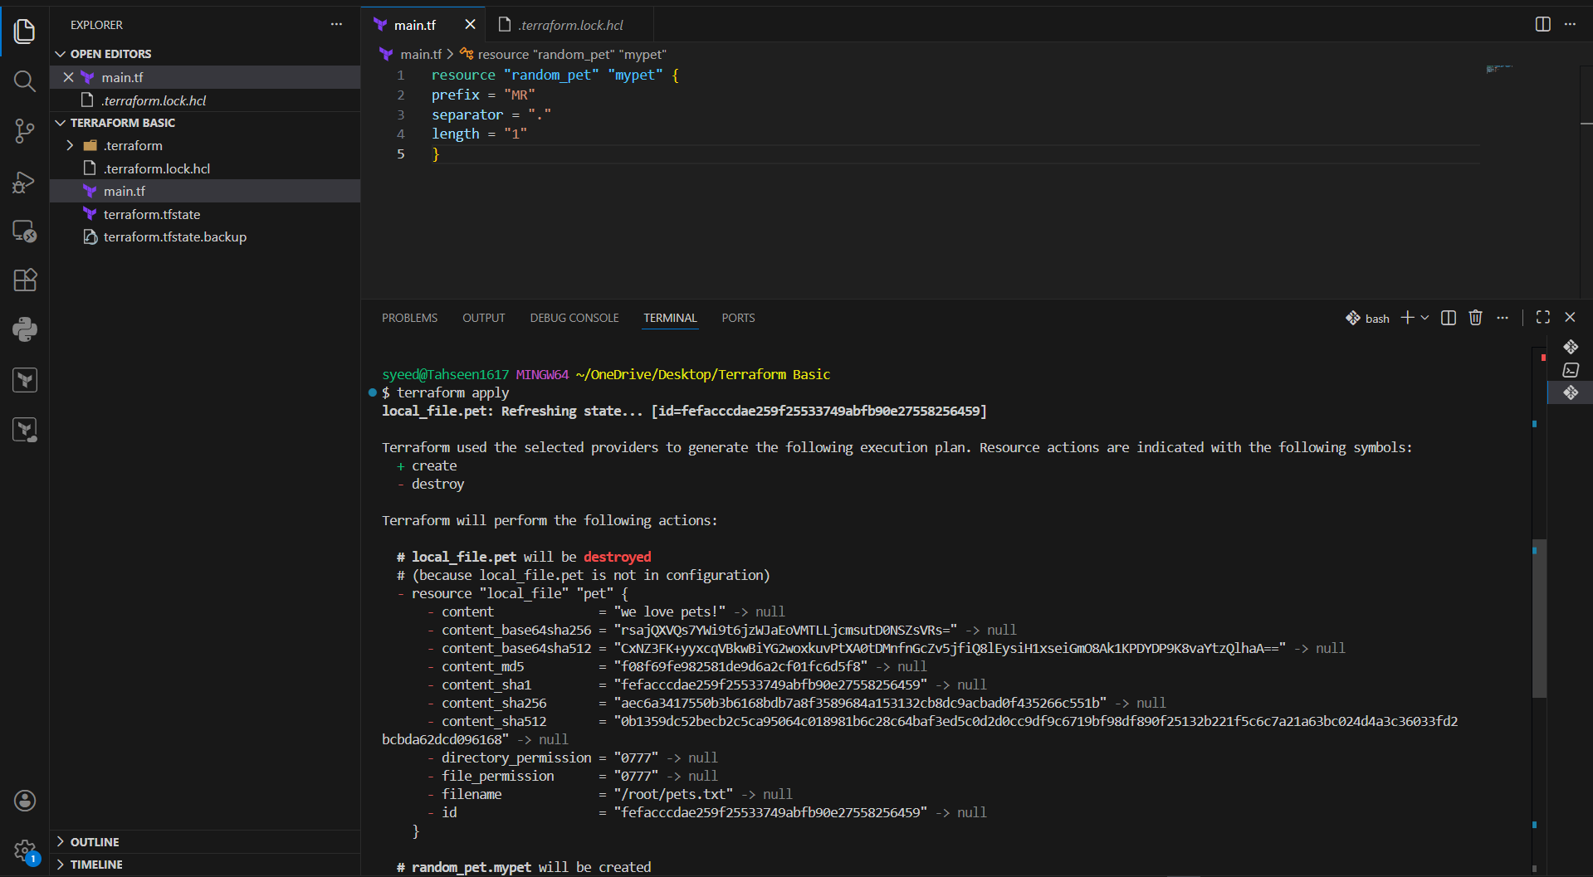

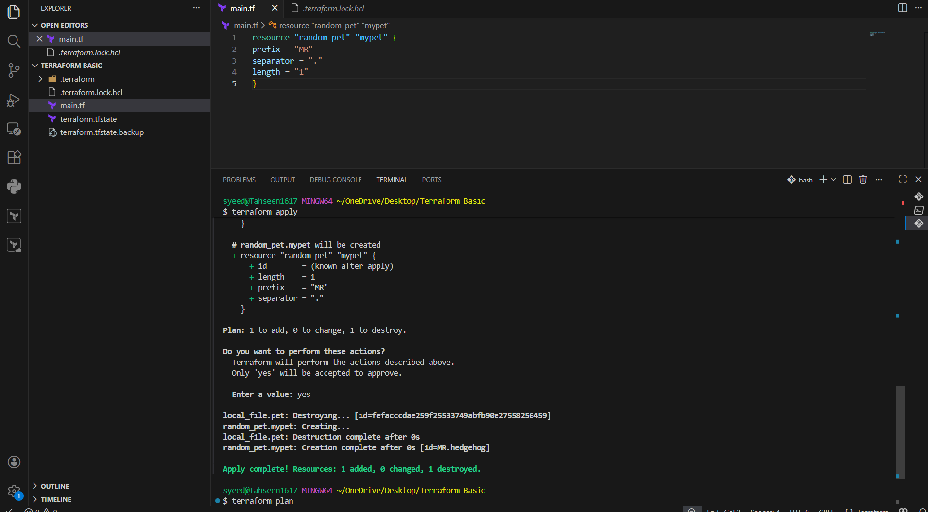
Run:
terraform plan
Terraform refreshes the state.
Output shows no changes.
Infrastructure matches the configuration

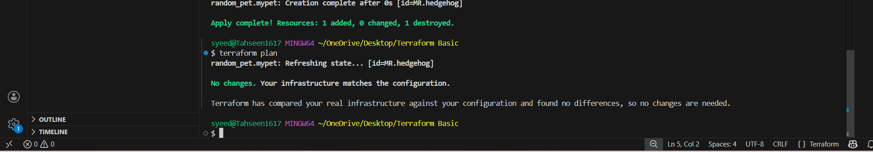
- Open terraform.tfstate in VS Code.
- Observe stored resource details.
- State file contains resource ID, attributes, and provider metadata.
- This file tracks the current infrastructure state.

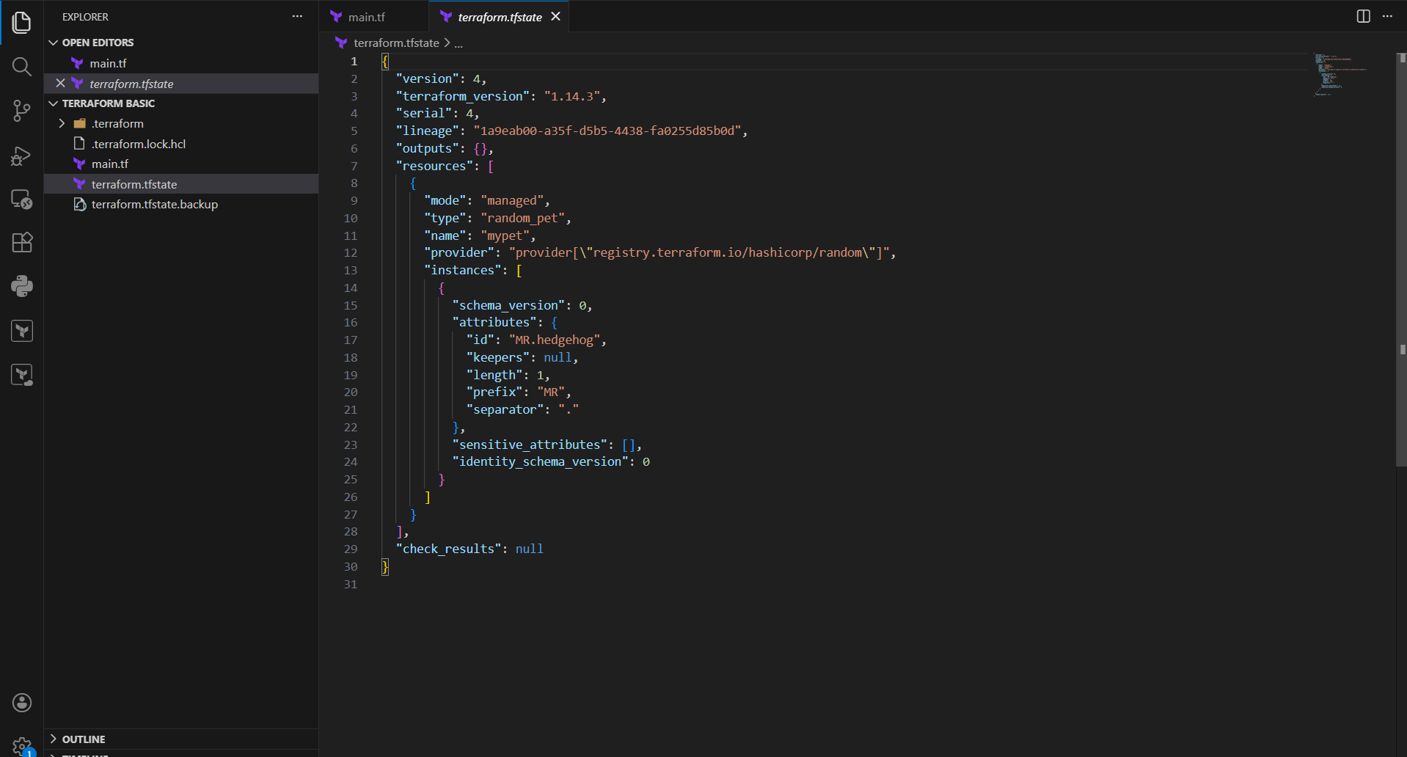

- Modify main.tf to use local_file resource again.
- Define filename and content.
- Save the file.
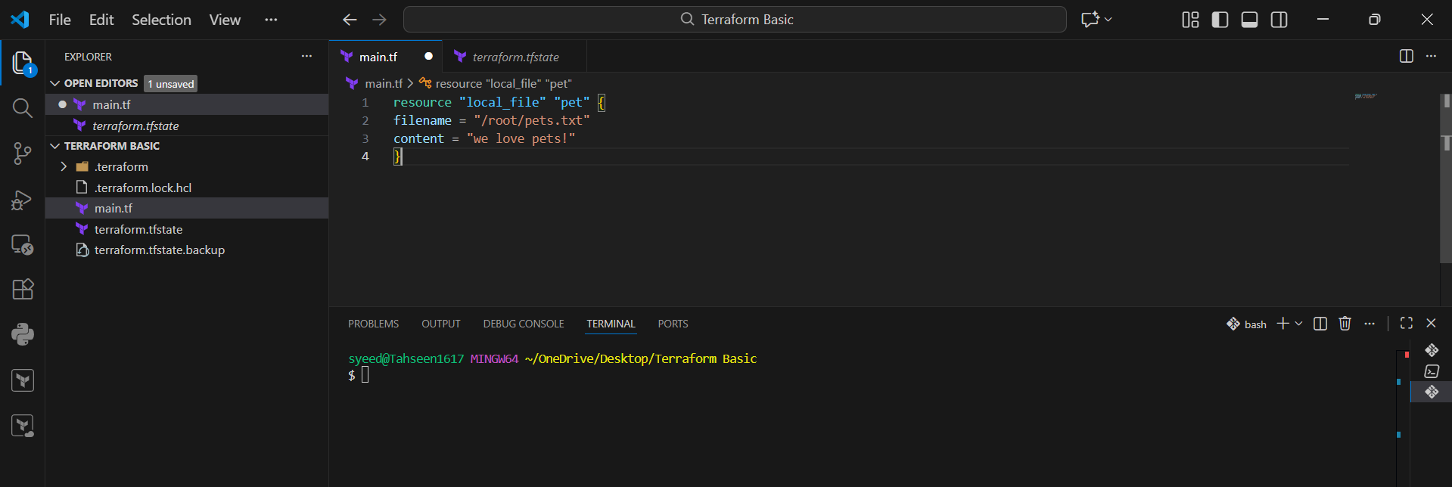
- Run:
- terraform init
- Terraform reuses existing providers.
- Initialization completes successfully

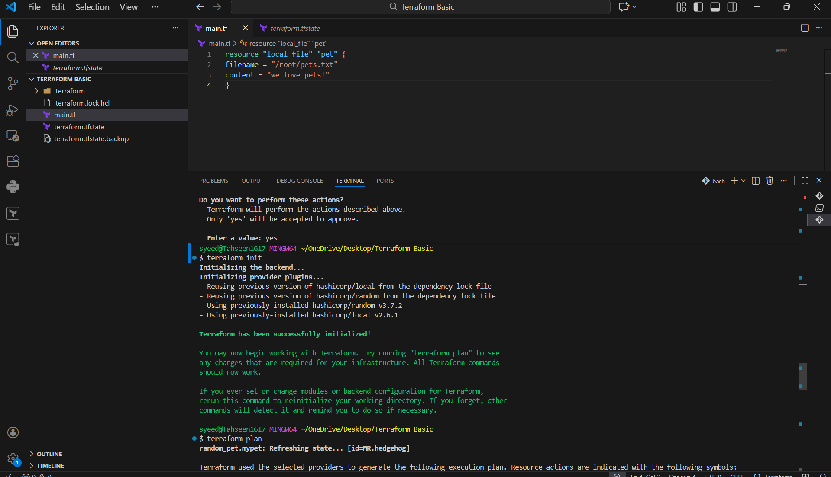

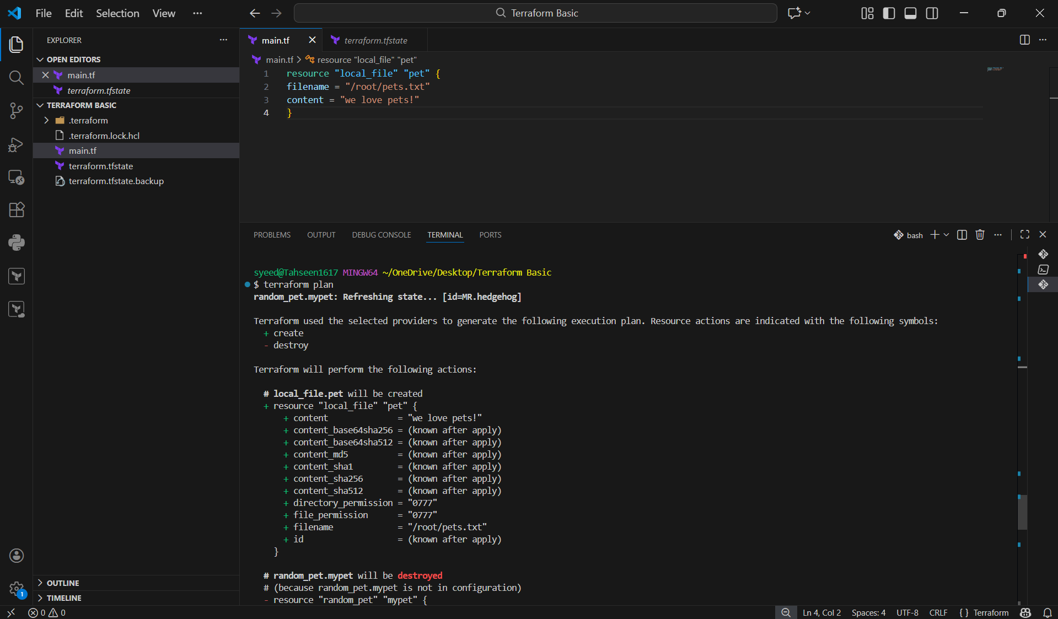
- Run:
- terraform apply
- Review the execution plan.
- Type yes to confirm.
- Terraform applies changes and updates the state file.

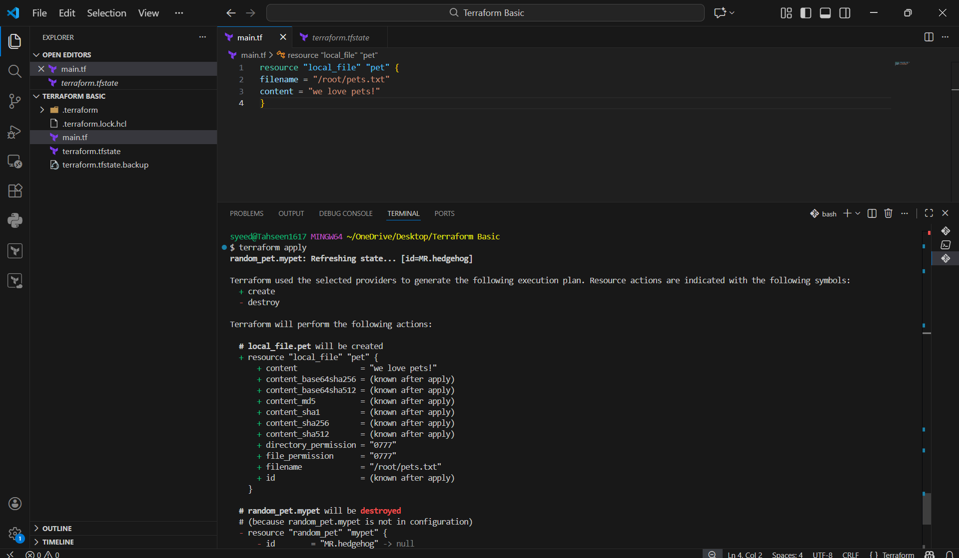

- Open main.tf containing the local_file resource.
- In the terminal, run:
- terraform destroy
- Terraform refreshes the state.
- An execution plan is shown indicating the resource will be destroyed.
- Terraform asks for confirmation before destroying resources

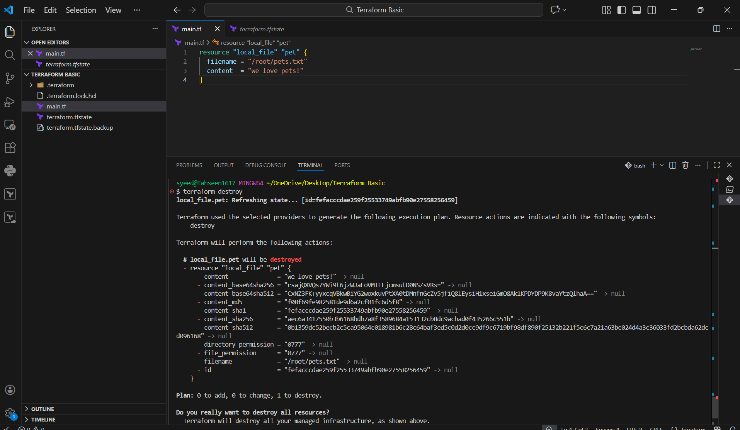
- Modify main.tf.
- Define the resource:
- Resource type: local_file
- Resource name: my_pet
- Filename: pet.txt
- Content: My pet name is Bruno
- Save the file
- Run the command:
- terraform init
- Terraform initializes the backend and providers.
- Then run:
- terraform plan
Terraform shows that a new local_file resource will be created

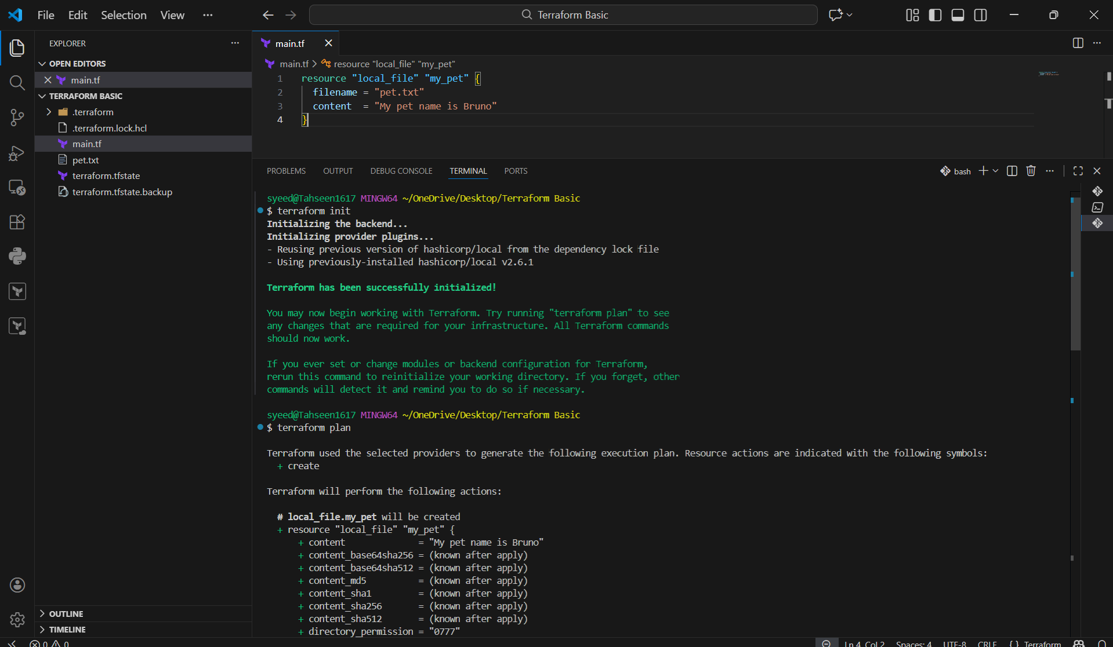
- Run:
- terraform apply
- Terraform displays the execution plan.
- Type yes to approve the changes.
- Terraform creates the pet.txt file.
- Apply completes successfully.

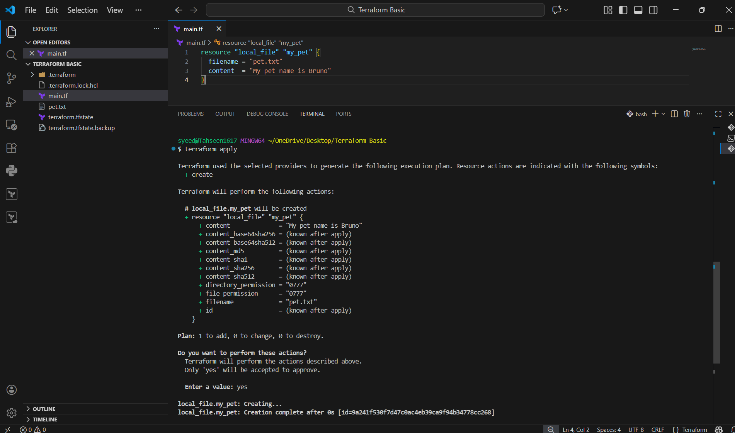
- In VS Code Explorer, locate the newly created pet.txt file.
- Open pet.txt.
- Verify that the content is:
- My pet name is Bruno
- This confirms Terraform created the file successfully.

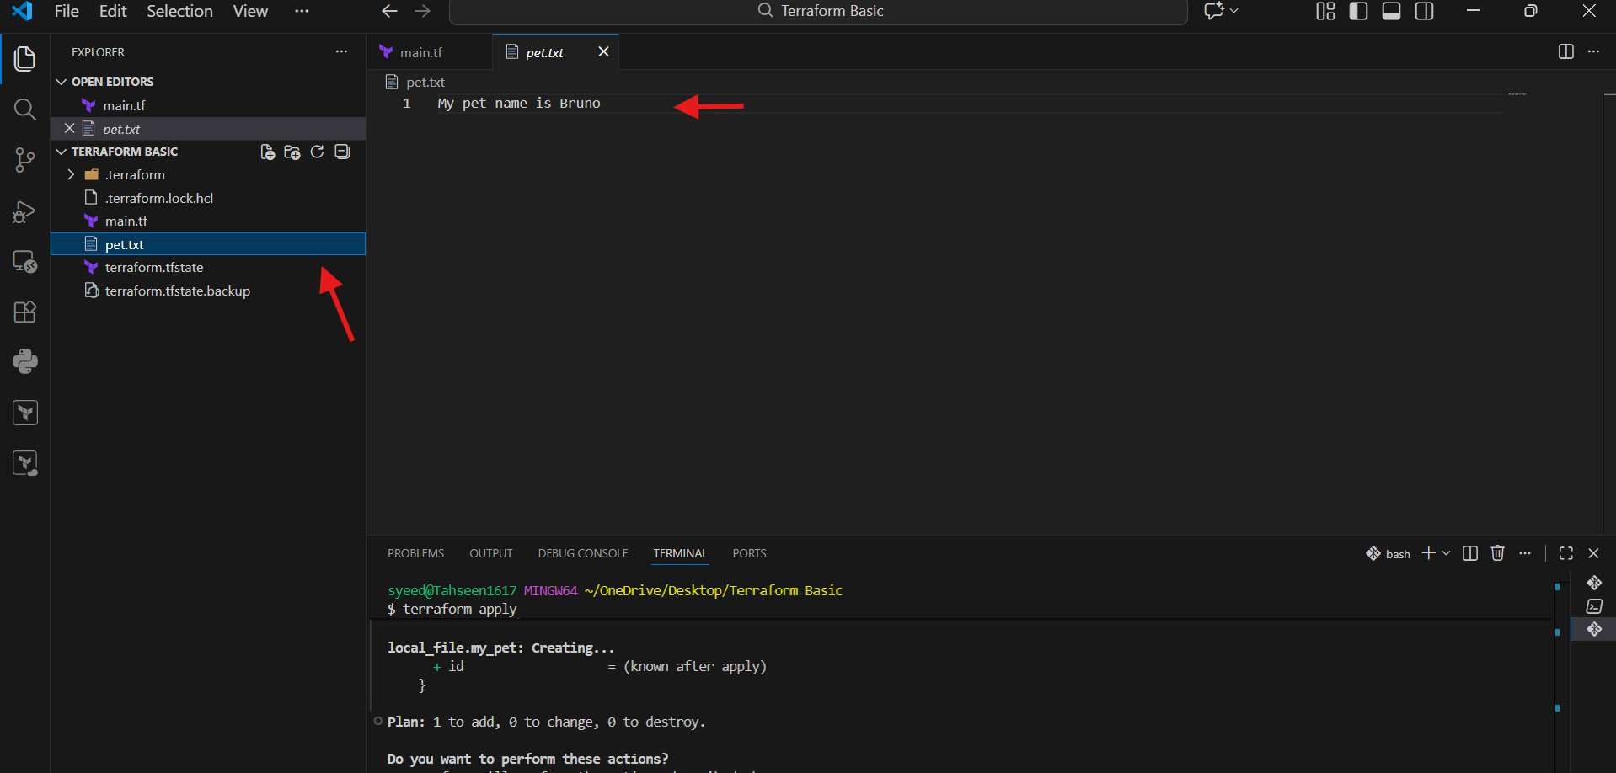

- Integrate a sample Terraform template in Jenkins.
- Open GitHub and click New repository.
- Enter the repository name as terraform.
- Choose visibility as Public.
- Enable Add README option.
- Click Create repository to finalize

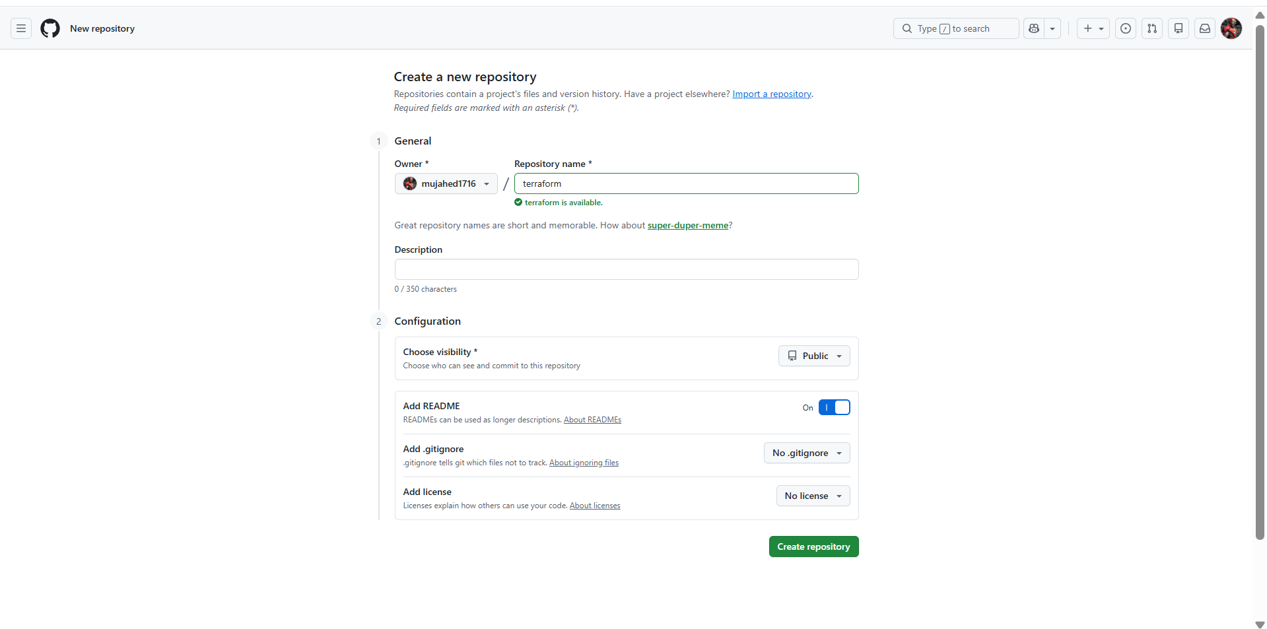
- Open the newly created repository.
- Create or edit main.tf.
- Add Terraform configuration:
- Define required providers.
- Use local_file resource.
- Add file name and content.
- Commit the changes to the main branch

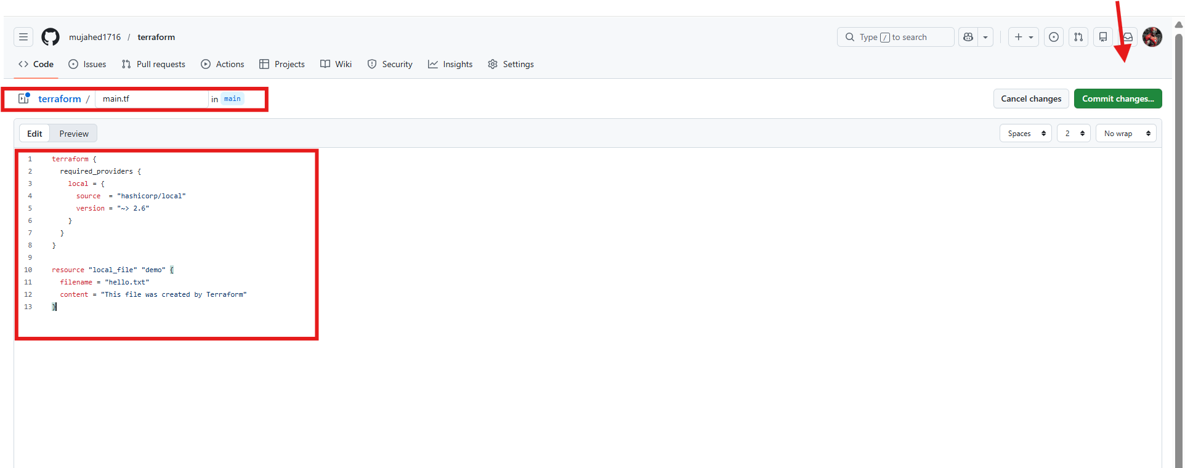
- Log in to the Jenkins EC2 instance.
- Add HashiCorp repository.
- Install Terraform using package manager.
- Terraform binary is downloaded and installed successfully.
- Verify installation completes without errors.

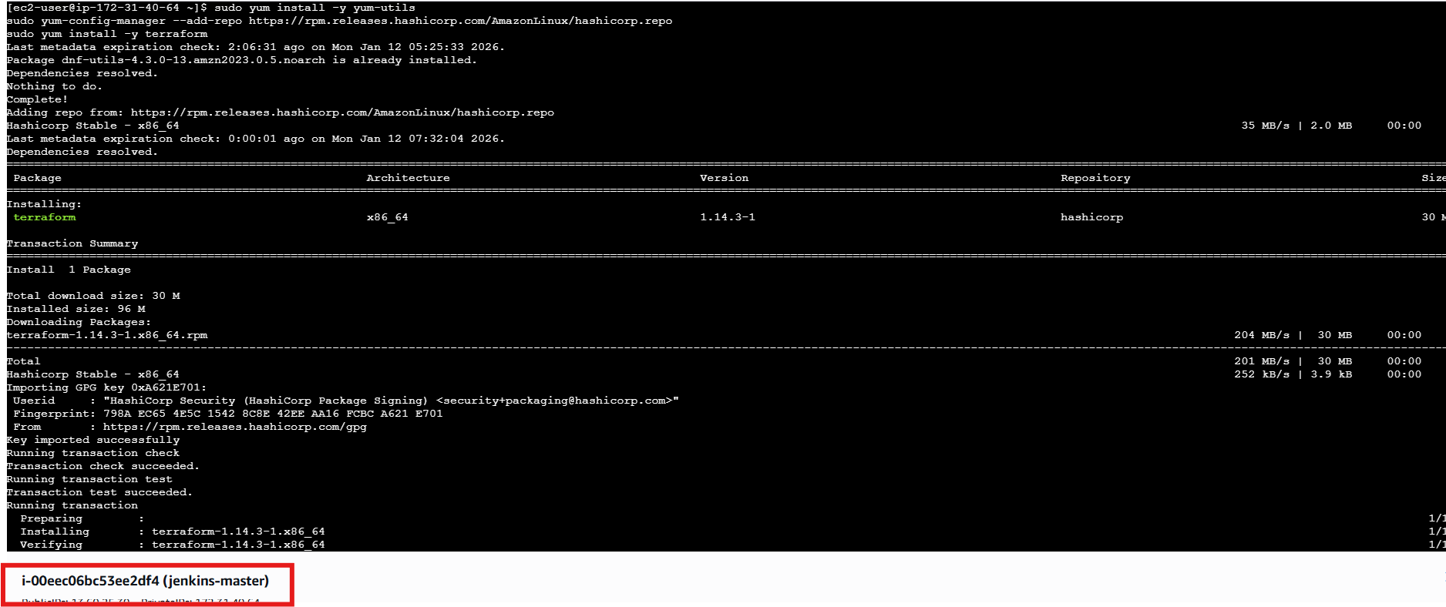
- Run:
- terraform -v
- Terraform version is displayed.
- Confirms Terraform is successfully installed on Jenkins server.

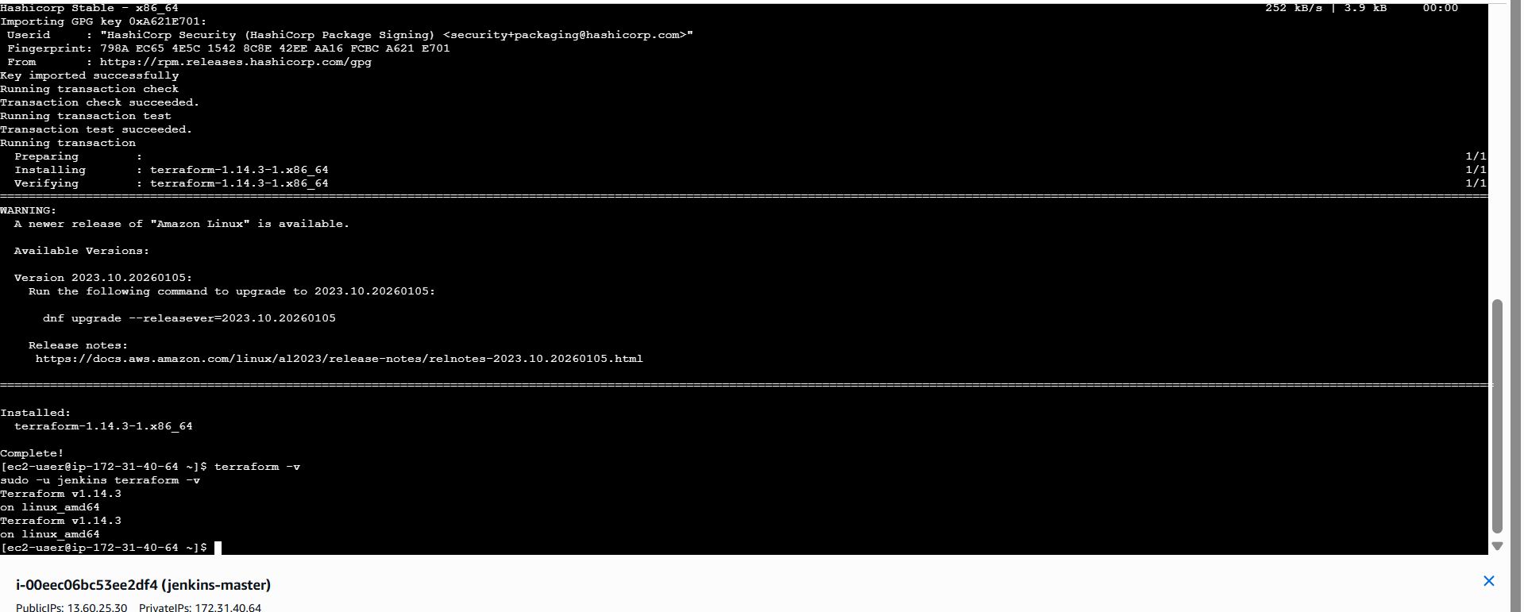

- Open Jenkins dashboard.
- Click New Item.
- Enter job name: terraform-pipeline.
- Select Pipeline as job type.
- Click OK.

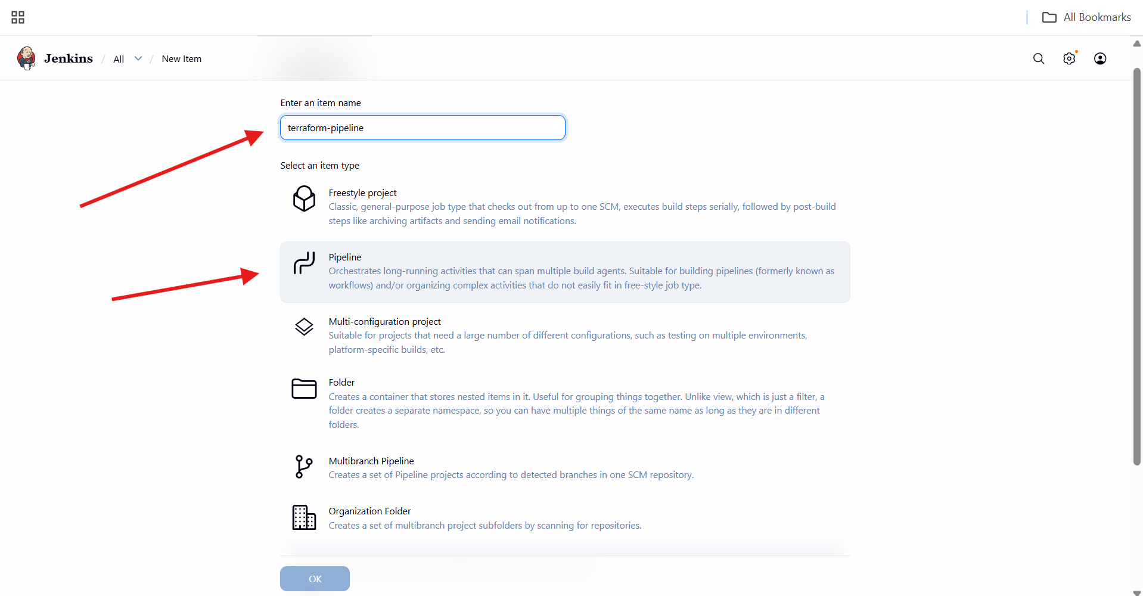

- In Pipeline configuration, select Pipeline script.
- Add stages:
  - Clone GitHub repository
  - Terraform Init
  - Terraform Validate
  - Terraform Plan
- Use GitHub repository URL in clone stage.

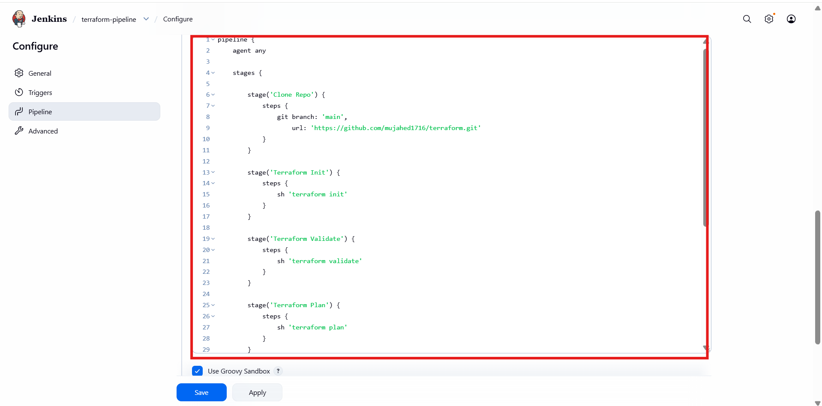
- Add Terraform Apply stage with auto-approve option.
- Add post actions:
- Success message on pipeline success.
- Failure message on pipeline failure.
- Save the pipeline configuration

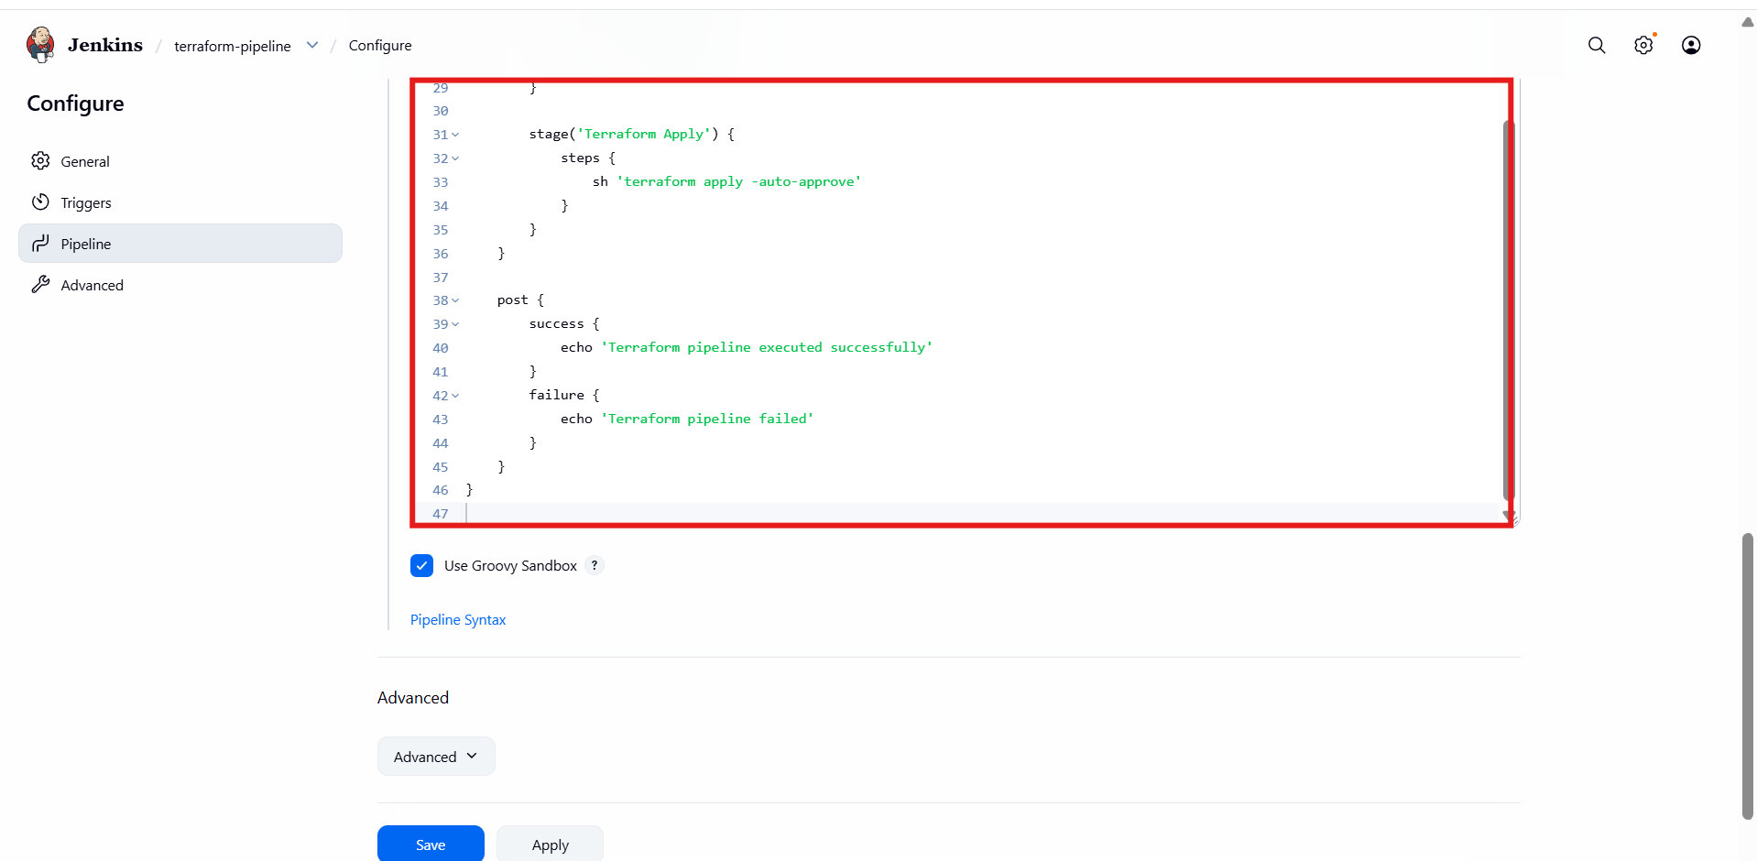
- Trigger the pipeline build.
- Jenkins executes stages sequentially:
- Clone Repo
- Terraform Init
- Terraform Validate
- Terraform Plan
- Terraform Apply
- All stages complete successfully (green status)

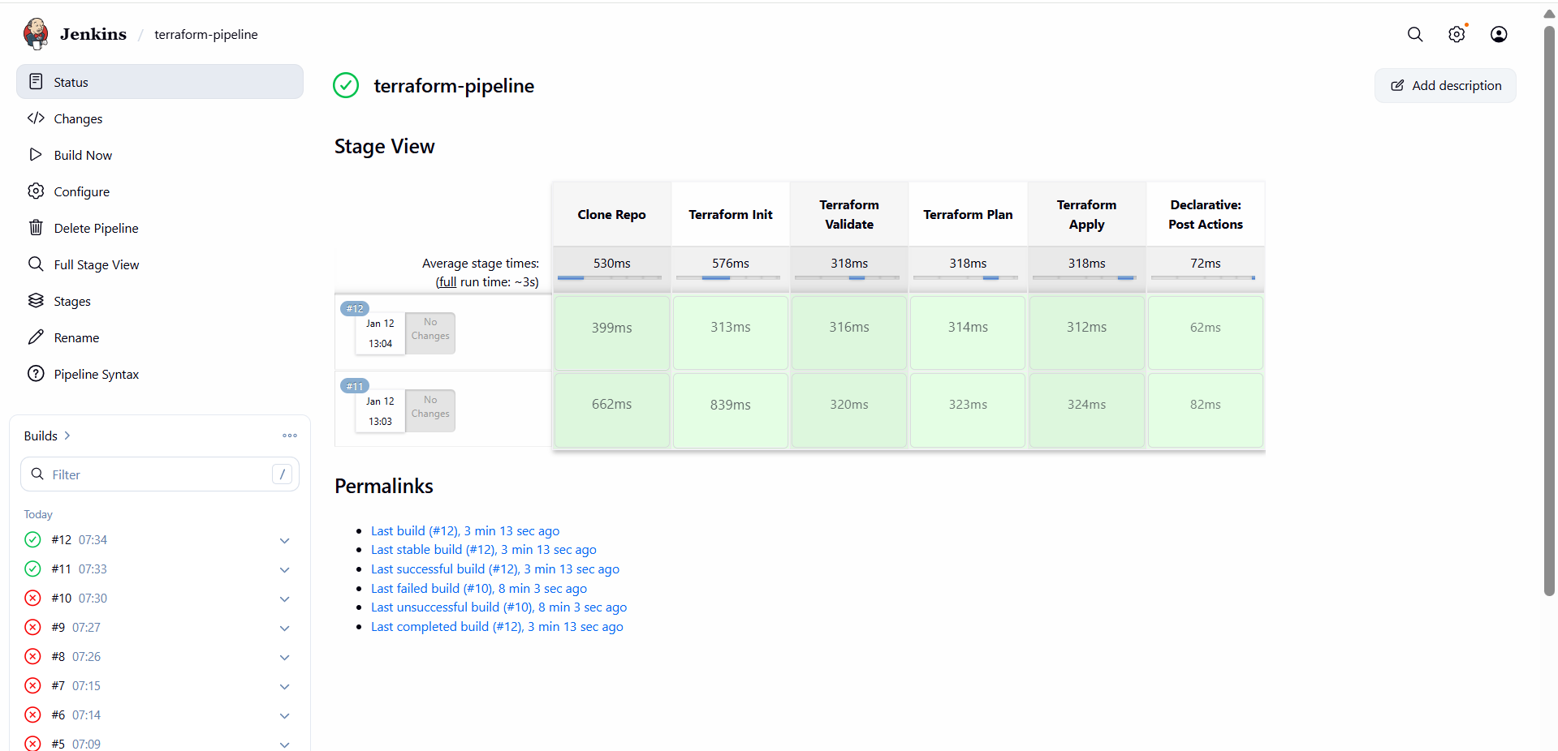
- Log in to Jenkins server.
- Navigate to workspace directory:
- /var/lib/jenkins/workspace/terraform-pipeline
- List files using ls.
- Terraform files, state file, and output files are present.

